LAB 4 Implement Virtual Networking

Hello! Here I will walk you through three labs that focus on virtual networking. After going over this lab you will have a better understanding on how virtual networking is set up in the cloud for your organization. This project was created to give you a real-world scenario of being tasked by your organization to implement a virtual network for your company. In this lab, we will be manipulating JSON files to include changes to IP ranges and Virtual network names. Also, we will be adding Network Security groups, Application security groups, and Azure DNS. I hope you enjoy. Be sure to check out AZ-104-MicrosoftAdministrator – Lab04 for this lab and many Azure resources.

Task 1: Create a virtual network with subnets using the portal.

Select: Virtual Networks

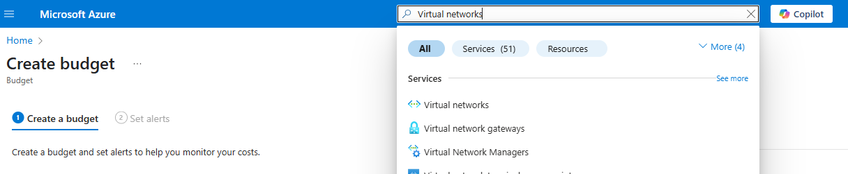

Select “Create”

Select a Resource Group and Type **CoreServiceNet1** as your Virtual network name (**Note:** This lab has been completed before. This document will differ from actual documentation posted in GitHub)

Select Next and skip Security. Go to IP Addresses tab and enter **10.20.0.0/16**

Remove the subnets **default** below

Select **Add a Subnet**

**Change the name Default to SharedServicesSubnet1** (**Note:** This lab has been completed before. This document will differ from actual documentation.)

Change starting address **10.20.0.0 to 10.20.10.0** and select **Add**

**Select Add** and change name **Default to DatabaseSubnet1**

Change starting address **10.20.9.0** to **10.20.20.0** and **select Add**

Select **Review + Create**

Select **Create**

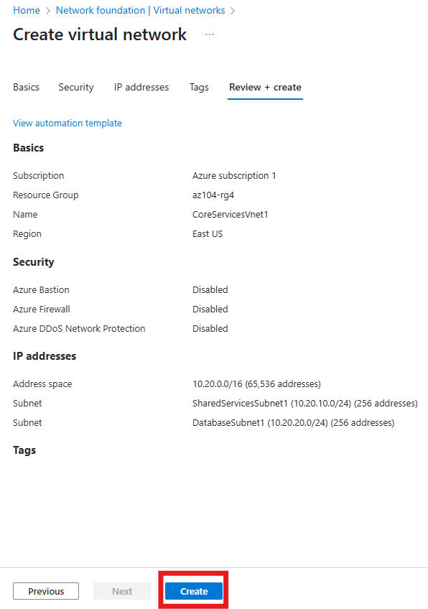

CoreServicesVnet1 has been deployed. Select **Go to resource**.

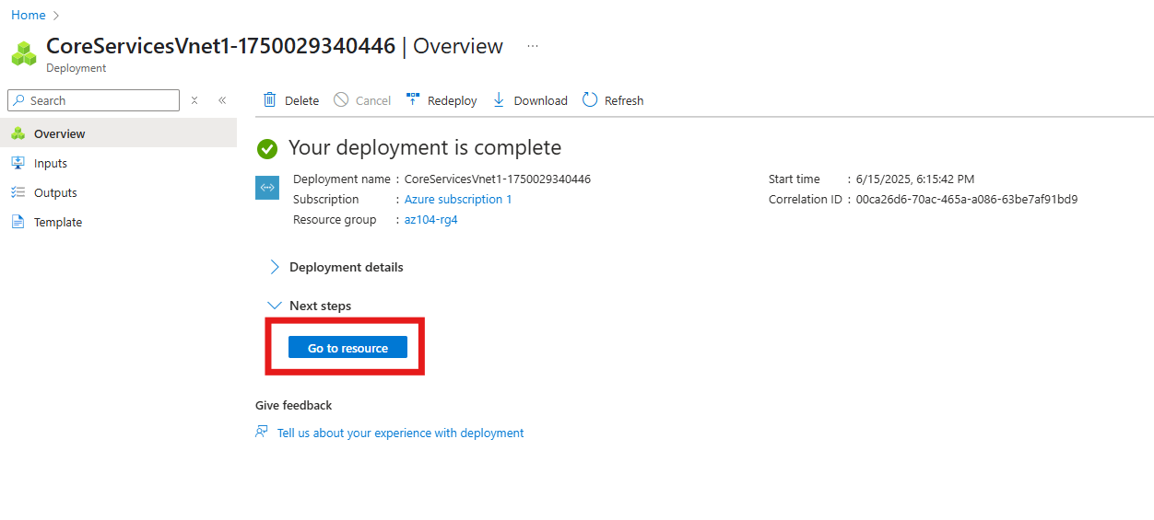

On the left side you can see your subnets when you select **Subnets** in **Settings**

Select **Export template** in **Automation** and wait for Template and Parameters code to generate

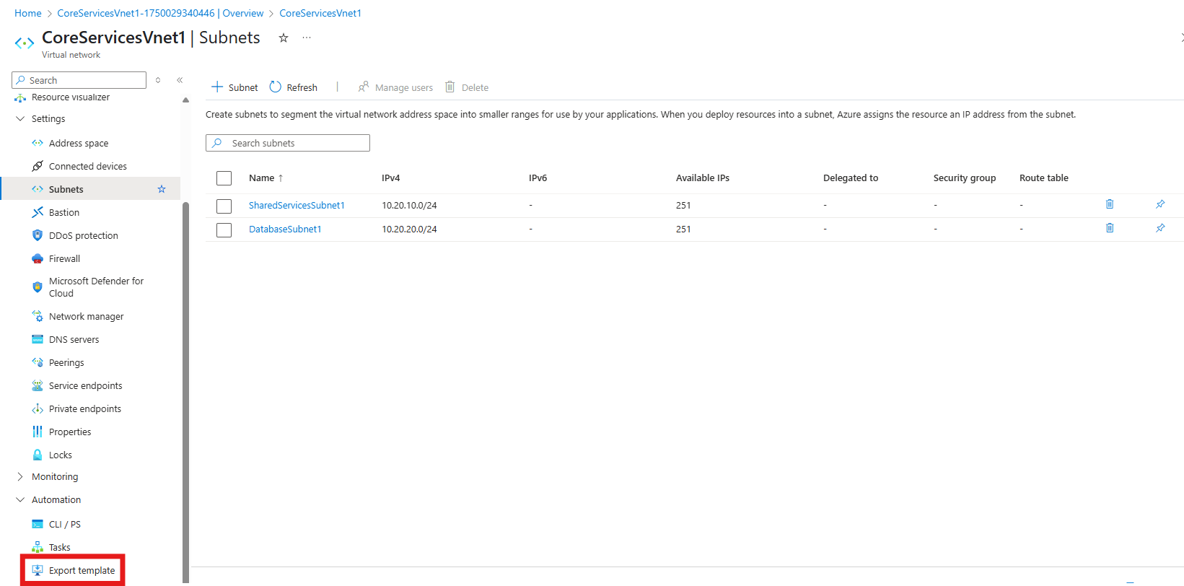

Select **Download**

Select **Extract All** on File



For the next step: Download Notepad++. You may run into issues compiling both JSON files.

Open **Template** with Notepad++

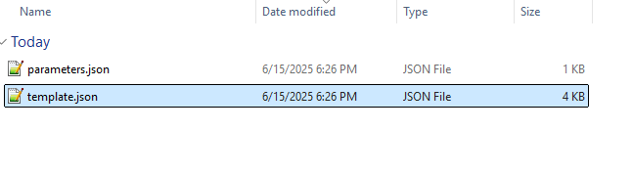

Change **CoreServicesVnet1** to **ManufacturingVnet1**

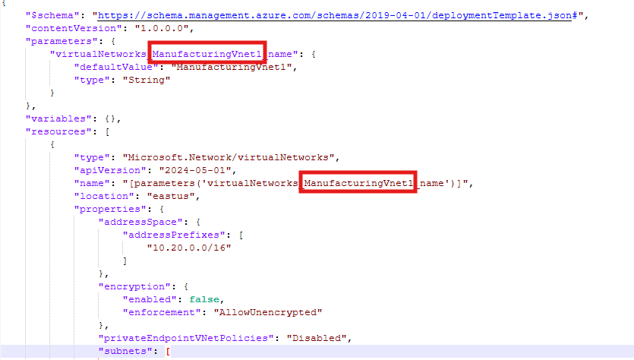

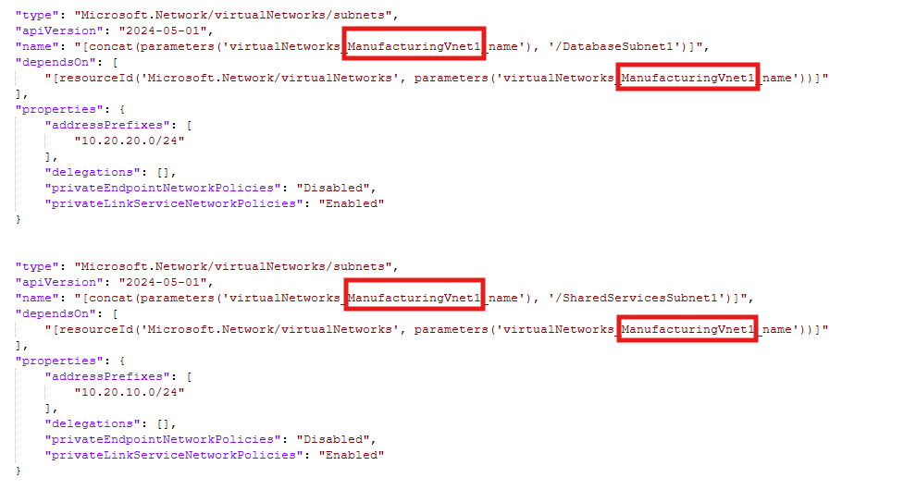

Next Change IP address range **10.20.0.0/16** to **10.30.0.0/16**

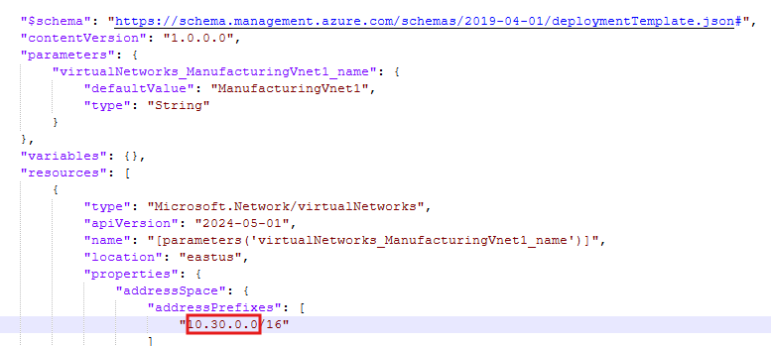

Change **SharedServicesSubnet1** to **SensorSubnet2**

Change IP range **10.20.10.0/24** to **10.30.20.0/24**

Change **DatabaseSubnet1** to **SensorSubnet3**

Change IP address range **10.20.20.0/24** to **10.30.21.0/24**

Hit **Save**

Select **File Folder** and Open **Parameters** JSON File

Change **CoreServicesVnet1** to **ManufacturingVnet1** and **Hit Save**

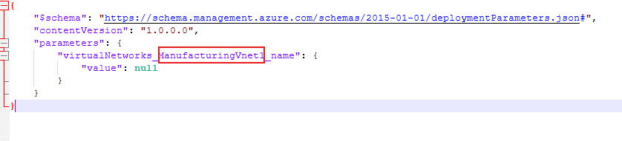

Go to Azure and type in the search **Deploy a custom template**

Select **Build your own template in the editor**

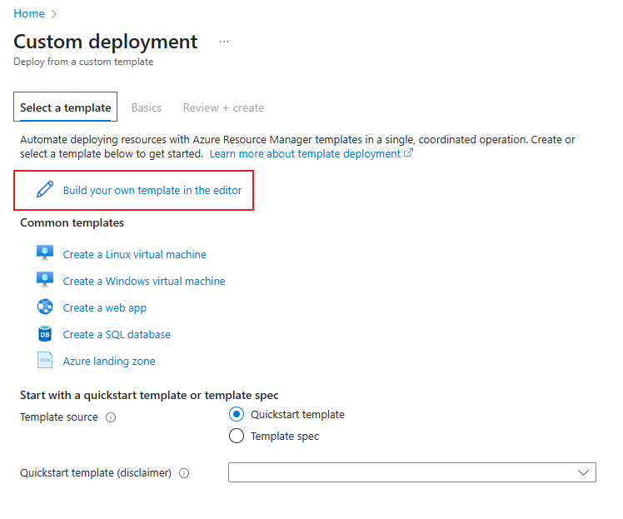

Select **Load File** and **Select Template** JSON

Hit **Save**

Next Select **Edit parameters** and Select Load File and click **Parameters** JSON

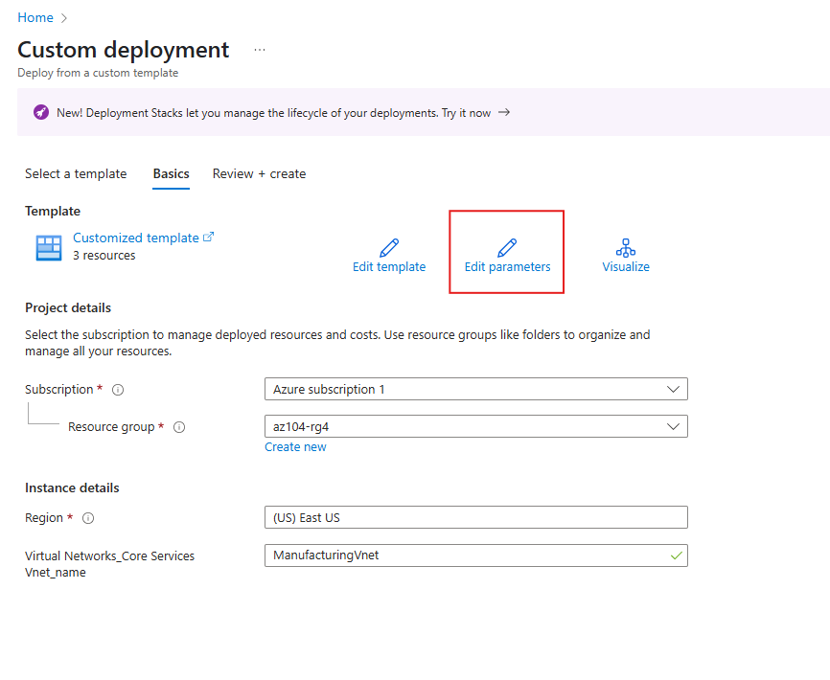

Hit Save

Select **Review + Create**

If this message appears select Basics tab and Hit edit parameters

Reupload Parameters file and hit save

Edit Template File and reload saved JSON Template file and Hit Save

Select Review + Create

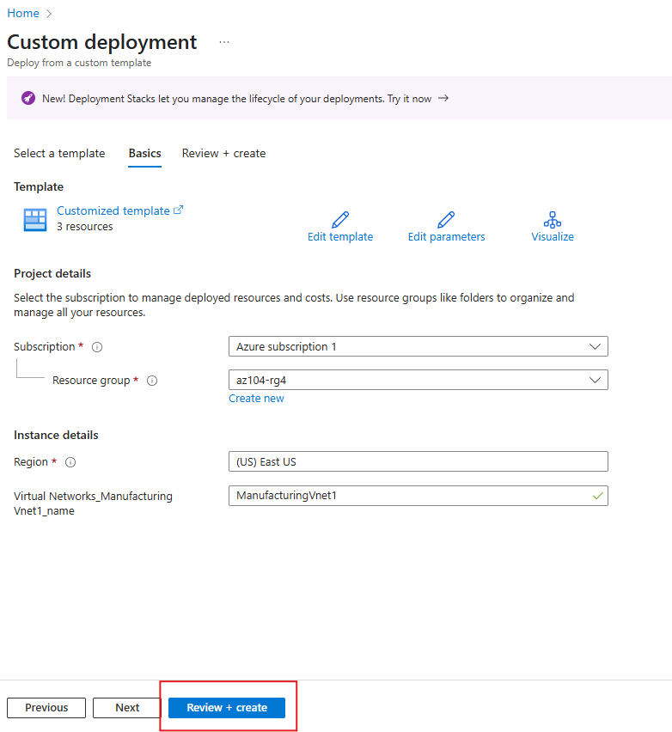

Review your configurations. When no error messages appear above, select **Create**.

Deployment is Complete. Select Deployment Details to see 3 Resources.

Select **Go to Resource group**

Type in the search **Application Security Group**

**Create New**

Select Resource Group

Under Instance details enter **asg-web1** in Name box and Select **Review + Create**

Select **Create**

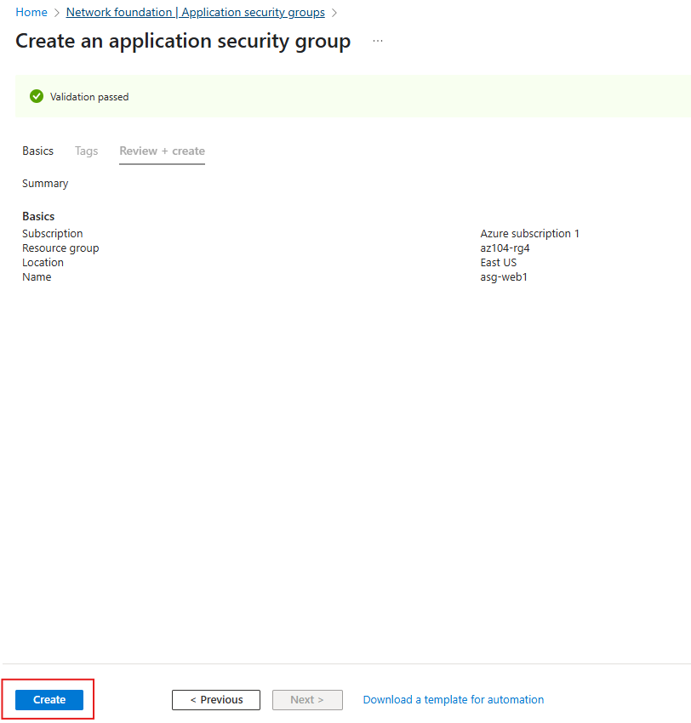

Open **Network Security Groups**

Create New Network Security Group

Select Resource Group. Enter **MyNSGSecure1** and Select **Review + Create**

Select **Create**

Select Go to Resource

On the left side select **Subnets** and Select **Associate**

Select **SharedServicesSubnet** and hit **OK**

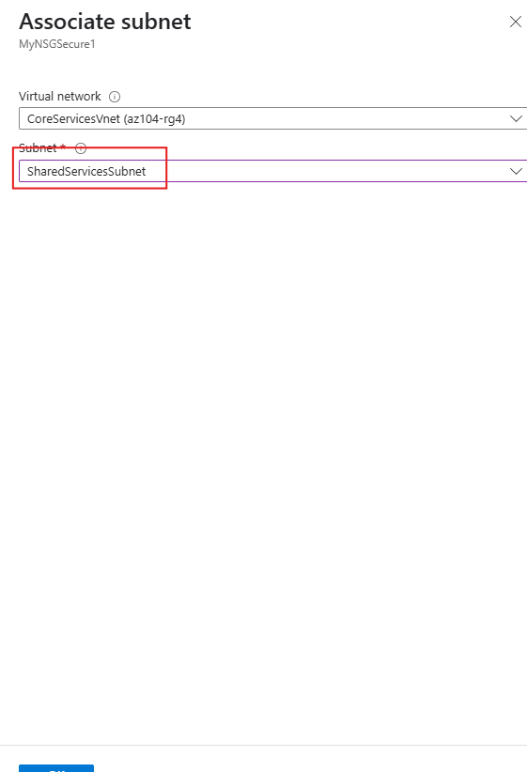

On the left under Settings Select **Inbound security rules** and select **Add**

**Enter the Following Configurations:**

Select: **Application security group** as Source

Select: **asg-web1** as Source Application Security group

Set Destination port ranges to **80,443**

Change protocol type from **Any** to **TCP**

Enter **AllowASG** as Name

Inbound Security Rule has been added

Select Outbound Security Rule and Hit Add

Change destination to **Service Tag**

change priority to **4096** and hit **Add**

Go to **DNS Zones**

Select **Create**

Enter **Cortosolk1.com** as the name and hit **Review + Create**

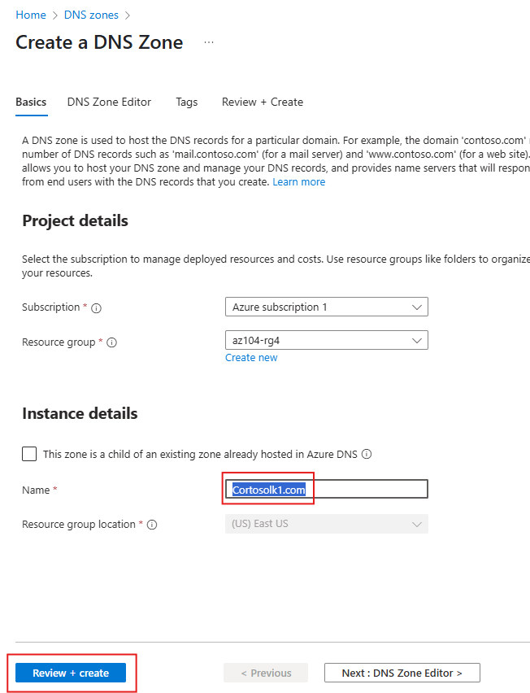

Select **Create**

Select Go to Resource

Select **Record Sets**

Enter **www** in Name, Enter **10.1.1.4** in IP address and select **Add**

Fire up a Bash terminal



Enter the following command: **nslookup** [**www.cortosolk1.com**](http://www.cortosolk1.com) **ns1-02.azure-dns.com**

Go to Private DNS Zones

Enter **private.cortoso1.com** and hit **Review and Create** and Select **Create**

Select **Go to Resource**

**Go to Virtual Network Links and select Add**

**Enter manufacturing-link1** as Link Name, Under Virtual Network select **ManufacturingVnet1**, and Hit **Create**

Select **Refresh** until Link Name appears

Under DNS Management select **Record Sets** and Select **Add**

Enter sensorvm1 under Name, enter **10.1.1.4** as IP address and select **Add**

